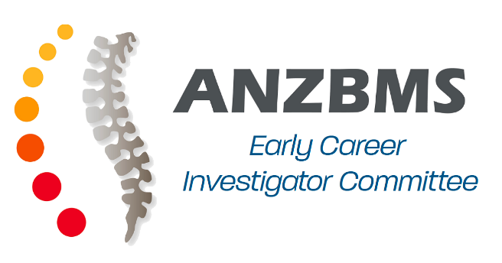

ECIC Application Form

Applicant details

Name:

Qualification/s:

Current position:

Institution:

Email:

Phone:

Mailing Address:

Are you a member of ANZBMS? Yes No

Do you meet the definition of an early career investigator*? Yes No
*A member of the ANZBMS who is currently enrolled in a higher degree or a current researcher within 10 years of award of a PhD/MD taking into account career interruptions.

Personal Statement
Please provide a short statement below, outlining why you would like to join the ECIC, what attributes and/or skills you will bring to the ECIC, and what future goals you have for the committee.
(maximum 300 words)

